Chapter 13, Solution 31.

Using Fig. 13.100, design a problem to help other students to better understand linear transformers and how to find T-equivalent and Π–equivalent circuits.

Although there are many ways to solve this problem, this is an example based on the same kind of problem asked in the third edition.

Problem

For the circuit in Fig. 13.99, find:

(a) the T-equivalent circuit,

(b) the Π-equivalent circuit.

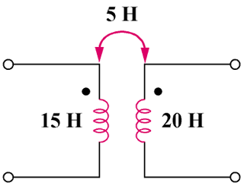

Figure 13.99

Solution

(a) L_{a} = L₁ – M = 10 H

L_{b} = L₂ – M = 15 H

L_{c} = M = 5 H

(b) L₁L₂ – M² = 300 – 25 = 275

L_{A} = (L₁L₂ – M²)/(L₁ – M) = 275/15 = 18.33 H

L_{B} = (L₁L₂ – M²)/(L₁ – M) = 275/10 = 27.5 H

L_{C} = (L₁L₂ – M²)/M = 275/5 = 55 H

